Acceptance Testing
UAT Execution & Report Submission

Date | 03 November 2022
Team ID | LTVIP2026TMIDS77573
Project Name | Explore with AI: Custom Itineraries for Your Next Journey
Maximum Marks | 4 Marks

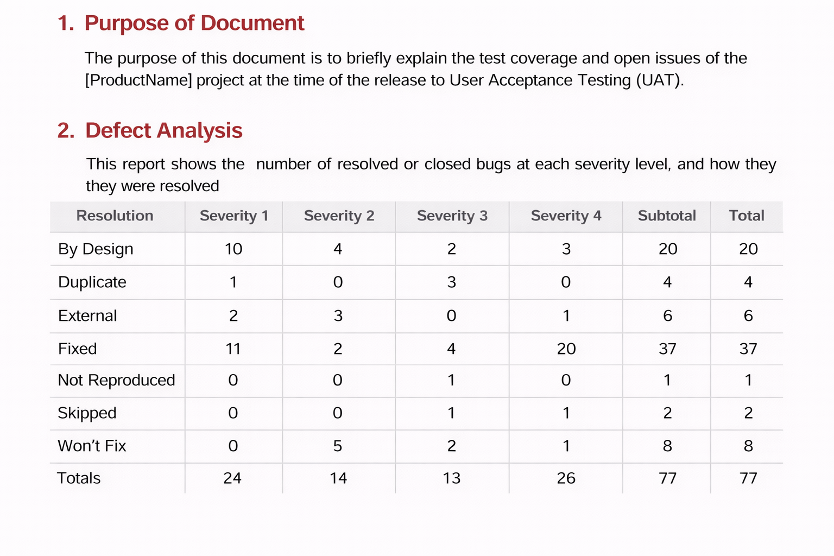

Test Case Analysis
This report shows the number of test cases that have passed, failed, and untested
Section | Total Cases | Not Tested | Fail | Pass
Print Engine | 7 | 0 | 0 | 7
Client Application | 51 | 0 | 0 | 51
Security | 2 | 0 | 0 | 2
Outsource Shipping | 3 | 0 | 0 | 3

Exception Reporting | 9 | 0 | 0 | 9
Final Report Output | 4 | 0 | 0 | 4
Version Control | 2 | 0 | 0 | 2

